CHRIST PRESBYTERIAN CHURCH NEWSLETTER
OCTOBER 2026

DEVOTIONAL:
All Hallows’ Eve is a time for reflecting on our mortal state, for acknowledging our natural fear of mortality and for remembering the various monsters and spooks that have given concrete shape to these fears across the centuries.

A WEEKEND WITH FRIENDS | FRIENDS OF THE GROOM:

A Weekend with Friends
led by Friends of the Groom Theater Company

Christ Presbyterian Church is thrilled to welcome the Friends of the Groom Theater Company! Join us for a weekend of fun and theological reflection through drama.

Are you interested in moving forward in your faith? Do you want to get to know others in the congregation better? Do you want to learn ways of sharing your faith creatively? Don’t miss this exciting weekend for all ages with a theater company that specializes in making the Christian message challenging and fun at the same time. There’s something for everyone: The performances, talks, and small group activities are designed to help each person grow in Christ and to build a sense of community. Along the way, the group
will use theater and storytelling to bring scripture and worship alive. So, if you’re a teacher, preacher, or performer looking for creative ways to communicate the gospel; or if you’re just someone who likes to watch, laugh, and think—come and enjoy this delightful time with friends old and new.

Friday, October 16th at 7:30PM
A delightful program of dramatic vignettes portraying beloved scripture and teachings of Jesus.

Saturday, October 17th at 10AM until 2PM
An interactive workshop that will inspire ways to use drama in worship and teaching the lessons of Christ and scripture.

Sunday, October 18th at 8:30AM and 10AM
Worship, where Friends of the Groom will help us explore aspects of stewardship and ways of offering our gifts to God.

To register or for more info email ruthcpctoledo@gmail.com
or call the church at 419-475-8629.
UPCOMING MEMORIAL SERVICES:
There will be a memorial service for Jim Findley on Friday, October 2nd at 11AM. Visitation will begin at 9AM. There will also be a memorial service for Mary Lee Fankhauser, mother of CPC Member, Tyson Fankhauser, on Friday, October 16th at 10AM. There will be a reception to follow in Scott Hall.

CHILDREN, YOUTH AND FAMILY MINISTRY:

SPIRITUAL SPARK:
Spiritual Spark is a faith formation class for children ages 4 - 5th grade. This class meets 11:30AM - 12:15PM on Sundays. It is an opportunity for children to gather in fellowship and faith formation. We will be looking at scripture & bible stories using the Spark Lectionary curriculum, and learning more about them through discussion, hands-on activities & crafts.

CPC ARTIST:
CPC Artist is back to meeting monthly! Our next class is Wed. Oct. 7th at 4:30PM. Children ages four and up are invited to our instructor-led canvas painting class to create a piece to display in our CPC Artist Gallery then take home. This class is free and all are welcome. Contact Catherine to register 516-659-9253

YOUTH LITURGISTS:
We are looking for liturgists for Sunday mornings! Let us know if the Spirit is moving you to serve as a liturgist. We have sign up links for our 10AM service for youth liturgists and acolytes, which can be found on our website under Resources, or in our weekly constant contact emails.

REKINDLE YOUTH RETREAT:
Youth grades 6th-12th are invited to participate in a presbytery wide youth retreat at Kirkmont Center November 6th - 8th. The cost is $15 per youth. Register by Oct. 15th https://maumeevp.org/rekindle-youth-retreat/

COLLEGE MINISTRY:
If you have a college student in your life that we can support, contact Karen Wharram karenwharram53@gmail.com with their name and address so we can include them in our college ministry!

BOUNDARY TRAINING:
For those in need of boundary training, the Synod of Covenant has three opportunities left for 2026. Find out more and register at: http://www.synodofthecovenant.ort/event-details/2026-boundaries-and-ethics-training-opportunities

October 21st | Wednesday Evening | 4PM - 8PM
November 2nd | Monday Morning | 10AM – 2PM
December 5th | Saturday Morning | 9:30 AM – 1:30 PM
PRESBYTERY LEADERSHIP RETREAT:
This will be held Nov. 1st - 2nd at Maumee Bay Lodge and Conference Center. Find out more info and register at: https://maumeevp.org/leadership-retreat/

WORLD COMMUNION SUNDAY:
This is taking place Sunday, October 4th. All of God’s people gather around the Table to celebrate the life, death, and resurrection of Jesus Christ. Part of the atonement that happens around this Table is reconciliation, which is the focus of the World Communion Offering. Experience the grace that comes from reconciling all peoples from all nations around the corner and around the globe through the ministry of this offering. Find out more: http://pcusa.org/special-offerings/world-communion-offering

COMMUNITY COMMITTEE BUILDING BEDS:
On October 10th we will be partnering with Christ the King to build 30 beds for children who don’t have a place of their own to sleep. All are welcome to participate and no skills are needed.

GRIEFSHARE:
GriefShare meetings have begun. We meet on Mondays at 6PM. Please arrive at least 15 minutes early your first evening to get enrolled. We'll start in Scott Hall with a supper prepared by the excellent cooks from The Corner. At about 6:30PM, we head to the Hospitality Room for discussion and a half hour video prepared by professionals from the GriefShare organization. We finish at 8PM. GriefShare is an international grief support group. Although GS is a Bible based program, people that are not Christians have benefitted from it. GriefShare is for those who have lost family members and friends. It is not designed for times when we suffer other forms of grief. We charge only $20, which is what we pay for the workbook we give participants from GS. We will meet every Monday night for 13 weeks. If you cannot attend all of the meetings, that's fine. If you have any questions, please speak with Howie Wharram (734.241.6316), Beth Bedwell or Carolyn Collins.

ANNUAL BONFIRE:
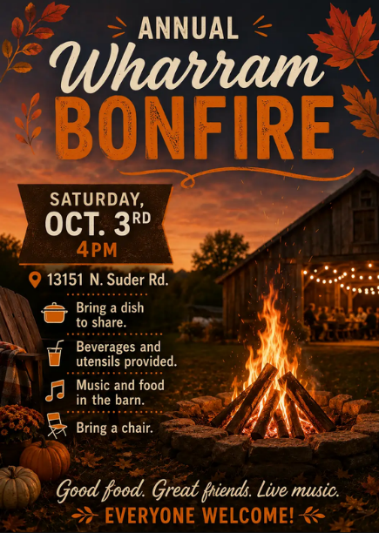
Karen and Howard Wharram will host their annual bonfire party Saturday, October 3, 2026. Live music will begin at 4PM. We'll light the fire a bit later. If the weather doesn't cooperate and we don't have the bonfire, we will still have the music and food in our barn. Please bring some food to share. We will provide beverages and utensils. You may want a folding chair. Please do not bring an RV. Please do not bring firearms or other weapons. If you bring a dog, please clean up after it. Our address is 13151 North Suder Rd., LaSalle, MI. Call 734.241.6316 or speak with Karen or Howard.

THANKSGIVING DINNER:
It’s not too soon to be thinking about the holidays. For the last two years, we have been able to
host dinner at the church on Thanksgiving Day for members and their families who would
otherwise be alone for the holiday or may not want to prepare a big meal and would prefer to
instead join with others of their church family. The event has been well received and attended,
and we would like to guarantee that this can continue as an annual tradition. But in order for
this to occur, we will need to have more volunteers involved. It may not be possible for all of
you to be here at church on the holiday itself, but you might be able to prepare some of the
side dishes ahead of time and deliver them to the church, or set up the tables and decorations
the day before. In addition, there will be the need for 4-6 volunteers on Thanksgiving Day to
setup the meal (2PM – 4PM) or to clean up afterwards (4PM – 6PM). Before we can begin to
advertise this event, we will need to guarantee that we have the necessary help needed.
Please contact Jan Whitaker at (419) 475-1265 or email at janwhitaker@aol.com to pledge
your support and indicate how you may be able to help.

CPC CHOIRS:
Our choirs need singers and ringers! Come try us out and enjoy the benefits: meeting a great group of people, lifting your heart in praise to God, and having fun (yes, we have fun!) Handbell and Chancel Choirs (high school - adult) rehearse on Thursdays at 6:15 and 7:15 respectively. Chancel Choir rehearsals begin on Thursday, Sept. 10th and Handbell Choir rehearsals begin the following Thursday, Sept. 17TH. Youth Choir (elementary - high school) rehearses on Sunday after our 10:00 service beginning Sunday Sept. 20th. Beginner instruction is available for any interested in ringing handbells who have not rung before. Watch for more information or contact Mark Mathias.

CPC DINNER GROUPS:

There’s still time to sign up for the Dinner Groups. Each individual or couple will be assigned a month to organize a date and place for a dinner or lunch. If you have been a member in the past, please sign up again. Please contact Diane McClellan 419-460 3413. We would love to have you join us.

STEWARDSHIP:
Here are the financial figures for January – August 2026

Total Income $305,757.34
Total Expenses $355,195.60
Net Income ($ 49,438.26)

CAR SHOW | OCTOBER 3RD LEADERSHIP RETREAT | NOV. 1ST – 2ND
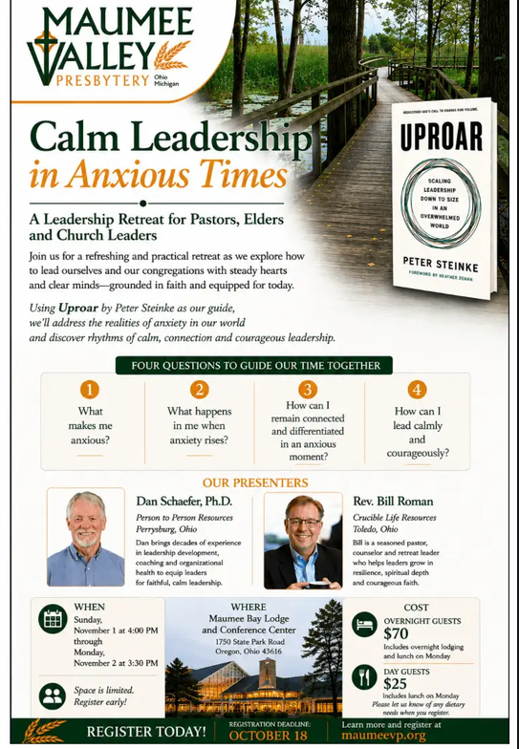


CELEBRATING BIRTHDAYS:
CPC members celebrating a birthday this month, we wish them a wonderful year ahead!

Keith Pearson; Cindy Wharram-Kendall; Bruce Parkhurst 10/4; Judd Collins 10/5; Larry Taylor 10/5; Bruce Poling 10/8; Jim Doughten 10/9; Lee Murr 10/10; Katie Wharram 10/10; John White 10/10; Liz Puskala 10/13; Jake Cisneros 10/15; Linda LaRue 10/16; Doris Rowan 10/17; Eric Bossenbroek 10/23; Sally Gladwell 10/23; Diane McClellan 10/23; Dick Lantz 10/29; Doug Aplin 10/31; Jon Bossenbroek 10/31; Karen Mauk 10/31.


If you don’t see your birthday listed in the newsletter during your birthday month, please let Susan Burklow know at seb61846@gmail.com and we will update our directory and celebrate you!

CARE AND CONCERN:

HOMEBOUND:
Mary Ignat, Jama Roman, Peg Locker, Harry Tubbs, Kathy McGannon

DEATHS:
Andrea Moen, sister of CPC Member Allison Johnson, died on September 9th

ONGOING CONCERNS:
Jim Burns, Allison Johnson, Kay Sellers, Judd Collins, Bill Drake, Dave McClellan, Richard Stambaugh, Sherry Gilbert, Barbara & Richard Brownlee, Don & Sandy Townsend, Margie Olson, Kathy Batdorf, Stephanie & Jenny Bell, Sanda Findley, Jean Oldham, Bruce Wharram, Katie Wharram

RELATIVES & FRIENDS:
Jane Lawson Larton (friend of Chris Vischer)
Nolan Thomas Dewire (friend of Bruce Bales)
Gary Mark (father of Todd Mark)
Gail Anderson (friend of Joni Pinkham)
Celina (friend of Jen Juhasz)
Family of Jim Findley
Jackie Fritze (sister in law of Carolyn Collins)
Monica Mancy & Family (friends of CPC)
Mrs. Edna Annanry (sister of Comfort Ofori)
Gail Williamson (niece of Carolyn Collins)
Lindsay Robertson Smith (former CPC member)
Andrew Stambaugh (son of Rick Stambaugh)
Carol Hunt (sister of Barb Easterly)
The World and our Government (Howie Wharram)
Gretchen Grana (friend of Jacquie Oiler)
Daughter of Carole Gildemeister
Mary Robinson (friend of Nanci Poling)
Sam Tekyimensah (friend of Comfort Ofori)
Loraine Gilley (friend of Bill Drake)
Stevie Linville (nephew of Kim Dedo)
Ryan Blocher (son of Carolyn Collins)
Alex (nephew of Jane & Phil Mintun)
Harel Carrier (friend of Bill Drake)
Terry Drake (brother of Bill Drake)

CLOSING PRAYER:
“Lord Jesus, we come before You today with a broken and contrite heart full of repentance. Please forgive me all my sins. Today, I surrender my life to You, I believe that Jesus is Lord and I confess it with my mouth. Jesus, come into my life and save my soul from eternal destruction in hellfire in Jesus’ name, I pray.”

