CHRIST PRESBYTERIAN CHURCH NEWSLETTER
DECEMBER 2025


DEVOTIONAL:
During this Advent, let us seek to be the builders of that peaceable kingdom foretold at Christmas, boldly committing to build a community that cares for the unloved, the unseen and the unheard. What if we discover once again that all we hunger for is in that ancient feeding trough that cradled a precious gift—a babe who would one day say, “I am the Bread of Life.” Merry Christmas, everyone!

REMINDER:
As winter approaches, you are reminded if Lucas County is in a Level 2 or 3 Snow Emergency, all church services & programming will be cancelled. Check your local TV stations for Level alerts.

Pastoral Reflection
This time of year, always makes me a bit sad. The high point for me is returning to Standard Daylight Time (that extra hour in early November really does make a difference for me). However, with the change in seasons, falling leaves, and the shorter daylight hours, I always feel a bit bereft. In one day, a tree, aflame with bright red leaves, is stripped bare by the cold winds that usher in the winter season that promises gray skies for months on end. It would be easy to stay in that place of sad, monotone, gray days. But I believe that God calls us to more.

We have come through our stewardship season and are looking ahead to next year. It is the hope of our leadership that we can provide a modest cost of living adjustment (COLA) to all of our staff as well as meet the continued maintenance demands of a large facility. Our program needs are running on reduced or unchanged budgets for several years. This is the time to prayerfully consider how you can support the mission and ministry of Christ Presbyterian Church through gifts of time, talent, and treasure.
The Nominating Committee is beginning its work to secure leadership for the upcoming class of 2028. Maybe the Holy Spirit is tugging on your sleeve to say yes to such a role as an elder or deacon. Maybe the tug is to serve on a committee that oversees one of our program areas (worship, education, administration, community/mission). If you are feeling such a pull, please talk to Jeff Lydy, who is chairing our Nominating Committee.

We are marching steadily forward into the holiday season and with it our GriefShare group is offering an event to help with “Surviving the Holidays” on Monday, November 24th from 6:00PM until 8:00PM. Howard Wharram can answer any questions you might have about that.

Jan Whitaker and Jody Zaiser are coordinating a Thanksgiving meal at 3PM on Thanksgiving Day—please make your reservation with them so that there is a place at the table for you.

Advent begins on Sunday, November 30th; during the 10AM worship service, we will receive our Confirmation Class into membership. We will also be using the daily devotional book entitled, The Advent Tree as the foundation of our Advent themes in worship. This book contains daily readings that go through Epiphany, January 6th. You are invited to pick up a copy of the book (see link in the article later in the newsletter) or to purchase one here at the church for $10.

The second Sunday of Advent is December 7th and we will gather at the Lord’s Table for Communion at both services. The third Sunday of Advent, December 14th will feature the Chancel Choir and Bell Choir for Advent Lessons and Carols—There will only be ONE SERVICE OF WORSHIP AT 10:00AM THAT DAY. This is always a special service in the life of our congregation as we prepare to welcome the Christ Child into the world. The Community Life Committee will host Second Sunday Luncheon that day.
Sunday, December 21st is the Fourth Sunday of Advent—ONLY ONE SERVICE OF WORSHIP AT 10AM THAT DAY.

Christmas Eve will feature two services of worship. The Family Service will be at 4PM and will feature our youth and children in worship leadership as we read the old familiar story and reflect on it. At 7PM, we will meet for worship featuring the Lord’s Supper and a service of candle lighting. Please invite your friends and family to these services which are highlights during the year and especially of this season.

The first Sunday of Christmas is on December 28th and will feature Christmas Lessons and Carols and special reflections on scripture—ONLY ONE SERVICE OF WORSHIP AT 10:00AM THAT DAY.
On Sunday, January 4th, we are back to two services, at 8:30AM and 10AM to observe Epiphany (the arrival of the Magi) and the Lord’s Supper.

With all that is coming up, it is hard to dwell on the gray skies. Let’s look instead for the places and moments when the sun breaks through the clouds and announces God’s presence with us and to welcome Emmanuel into our midst with joy.

See you Sunday!
Pastor Ruth

ADVENT AND CHRISTMAS SCHEDULE:

- Hanging of the Greens will be Sunday, November 23rd after the 10AM worship service. Please stay and help decorate.

- Worship Services are at 8:30AM and 10AM on Sundays November 30th and December 7th.

- Communion will be served on December 7th, the first Sunday, as usual.

- There will be no 8:30AM service on December 14th, 21st and 28th. On December 14th there will be Advent Lessons and Carols. On December 28th there will be Christmas Lessons and Carols.

- Wednesday, December 24th, Christmas Eve services will be 4PM Family Service and 7PM the Christmas Eve Service serving Communion.

- Worship services will resume for 8:30AM and 10AM services on January 4th.

THANKSGIVING DINNER:
Come join us for dinner at the church at 3PM on Thanksgiving Day, November 27, 2025. We will provide the meal; you will provide the fellowship. For those of you who would be alone on the holiday and those who would enjoy celebrating the day with your church family, we encourage you to sign up on the sheet inn the narthex so that we have an estimate of how many folks to cook for. Let us join together as we thank God for our many blessings.
CHRISTMAS POINSETTIAS:
You may order poinsettias either with an on-line order form in Constant Contact or on an order form obtained from the church. Please indicate on the form if you will be donating the plant or taking it home with you. The cost is $10 per plant and the deadline for ordering is December 10th. Contact Carol Gildemeister if you have any questions. cgildemeister@buckeye-express.com.

COMMUNITY COMMITTEE:
The Community Committee is having a Christmas Giving Catalog this holiday season. It is a great way to support the activities in our church and to give a gift to the people on your list who are impossible to buy for. Beginning the Sunday before Thanksgiving, members of the CC committee will be out in the narthex with the gift catalog. A handmade card will be given out to the recipient. We ask that the congregation not bring used items to Hansen Hall. With basketball season starting, there is no room to store the items. Used items can be donated to Goodwill or the Salvation Army.

Once again, we will be participating in Building Beds next fall. Donations of twin bedding will be needed. Be on the lookout for items during Black Friday and after Christmas sales.
December Feed Your Neighbor is requesting canned fruits and vegetables.

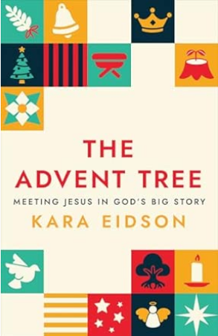
THE ADVENT TREE:
“The Advent Tree” this Advent season we will be using this book as a devotional. Here is a brief description of the book: Inspired by the centuries-old Jesse Tree tradition, pastor Kara Eidson presents forty Scriptures from across the Bible to explore how Jesus, his family, and followers were shaped by all that had come before him—the epic story of God and God’s people—and how we, too, are part of God’s story as followers of Christ today. Enhanced by daily illustrations symbolizing each Scripture, this Advent study and devotional guides readers from ancient stories and prophecies to the manger and beyond to deepen faith and grow in appreciation of Jesus as Messiah.

Here is the Amazon link: The Advent Tree: Meeting Jesus in God's Big Story: Eidson, Kara: 9780664269319: Amazon.com: Books
The church has a few copies for $10. If there is enough interest we can order more at that discounted rate. Advent begins November 30th.
Coloring pages are available along with smaller images you can use at home to create your own advent tree. We will be sharing weekly videos in the chapel.

CAROLING AT “THE CORNER”:
We are looking for carolers! Can you help share the joy of Christmas with others by joining in singing familiar Christmas Carols on Monday, December 8th at the Corner? If there’s enough interest, we will meet at 5:10PM in the music room and carol from 5:30PM – 5:45PM. You can sign up in the narthex. If you would like to join us for this and have questions, please contact Markcpctoledo@gmail.com .


STEWARDSHIP:
A snowy Sunday arrived for Dedication Sunday on November 9th! A delicious Second Sunday luncheon with cake and cookies was enjoyed by all who could attend services. Dedication Sunday is when we make our commitments of time, talent and treasure to CPC for the year ahead. Please prayerfully consider your financial gifts to the 2026 Operating Fund. One of our greatest hopes for 2026 is to give the CPC staff a cost-of-living increase. If you were unable to attend on November 9th, please mail or email your pledge card to CPC or bring your card when you attend Sunday Services. If possible, please return your pledge by Sunday, December 7th to help the Administration Committee and Session plan for 2026.

Howie Wharram inspired all of us through his sermon “Blest to Be a Blessing” on October 19th (you can view on the CPC website) and Keith Pearson updated us on the work of the Vision & Strategy Committee October 26th. Phil Mintun as Chairman of Stewardship gave comments on Dedication Sunday. If you have any questions or did not receive a pledge card in the mail, please contact Amalya at amalyacpctoledo@gmail.com or Phil Mintun at psmintun@gmail.com. Thank you for your gifts to CPC!

Per Capita is $40.29 per member. Please be sure to label “per Capita” when submitting to Amalya.

January – October 2025
Total Income $422,715.96
Total Expenses 431,184.36
Net Income ($ 8,468.40)

CHILDREN & FAMILY MINISTRY:
Family Retreat: Save the date! We are thrilled to announce we have booked Goodrich lodge at Kirkmont for our Family Retreat on February 6th – 8th. More info to come so mark your calendars!

If your child/youth would like to help lead the Family Christmas Eve Service worship service, please contact Jencpctoledo@gmail.com.

Kid’s Day will be offered on January 19, 2026 and will need volunteers to help plan and lead activities for a day filled with fun and faith formation. If you would like to help, please contact Jen Juhasz.


Youth Volunteers: We would love to get more youth involved in helping with our children’s ministry!
If you would be interested in preparing a piece of the lesson for spiritual spark or refreshing the praygound, contact Jencpctoledo@gmail.com.

CPC Artist: CPC Artist will meet on Tuesday, December 2nd at 4:30PM. Children ages 4 and up are invited to attend this instructor led canvas painting class. The class is free and advanced registration is required by contacting Catherine at 513-659-9253.
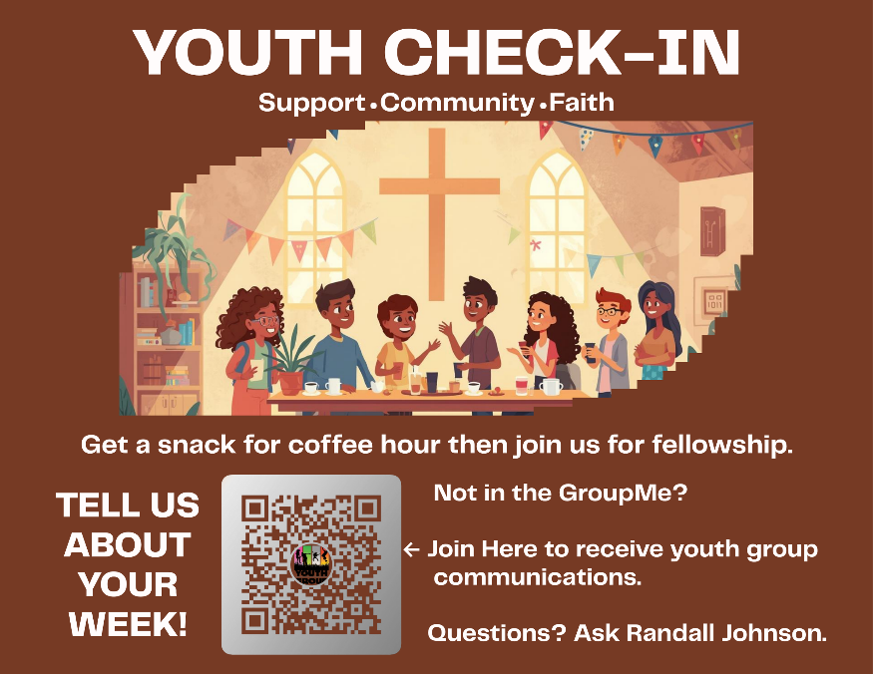
Tuesday School: The CPC Tuesday School Christmas Program will be Tuesday, December 9th at 6PM with a cookie reception afterward. Keep our students and families in your prayers.

Youth Check-In: Come on down for coffee hour and gather at the youth check in table! We want to see you and hear how you are doing and find out what we can hold in prayer for you.

Youth Group: Join us the first Sunday of each month beginning January 4th at 11:30AM in the youth room as we gather for fellowship, faith formation and fun!

BEAT THE BULLIES: NO CAP ON KINDNESS
In a world that can sometimes feel negative, judgmental, or just plain mean, it’s more important than ever to take an all-in approach to creating a life where everyone feels welcome, valued, and safe around you.

Refusing to settle for a culture of bullying, drama, or peer pressure is the key to building an environment where we all can thrive — mentally, emotionally, and socially. In this session, you’ll get real talk, real data, and real stories that will make you laugh, maybe tear up, and definitely think differently about how you treat others (and yourself). You’ll walk away with practical ways to build empathy, show kindness, and create positive change in your world and your story. Because the best investment you can make… is investing in people — starting with you.

Sunday, January 11th from 6PM – 7PM

WORSHIP COMMITTEE:
The Worship, Music and Arts Committee need volunteers for Ushers. Please contact Bill Drake, Head Usher, if you are available. duckkfeet@yahoo.com.

SECOND SUNDAY:
The Community Life committee will be hosting the Second Sunday Lunch after the 10AM worship service on December 14th. Mr. and Mrs. Claus and their Elves will possibly be making an appearance! Join us for a special day of fellowship and food!

CARE AND CONCERN:

Homebound:
Jama Roman, Harry Tubbs, Peg Locker, Mary Ignat

Ongoing Concerns:
Jack Rogers, Gary Connor, Kay Sellers, Tim Pryor & Betsy Gouvernayre, Judd Collins, Bill Drake, Jack Rogers, Dee Tilley, Dave McClellan, Richard Stambaugh, Christine Vischer, Harry Tubbs, Sherry Gilbert, Barbara & Richard Brownlee, Don & Sandy Townsend, Margie Olson, Kathy Batdorf, Linda Bell, Stephanie & Jenny Bell, Jim & Sanda Findley, Jean Oldham, Bruce Wharram, Katie Wharram

Deaths:
Anne White, sister of Jeannie Miner & former CPC member, died on November 17, 2025

Relatives and Friends:
Stu Drake (son of Bill Drake & Kay Sellers)
Kathryn (friend of Jen Juhasz)
Sam Tekyimensah (friend of Comfort Ofori)
Loraine Gilley (friend of Bill Drake)
Stevie Linville (nephew of Kim Dedo)
Maverick (6-month-old friend of Kim Dedo)
Fred Heumann (Missionary)
Jim Armagast (father of Brandon Armagast)
Ann Saudmore (Hattie Kate Howell)
Judy Clendenin (mother of Rev. Ruth E. Clendenin)
Ryan Blocher (son of Carolyn Collins)
Doug Holdridge (brother of Karen Start)
Alex (nephew of Jane & Phil Mintun)
Harel Carrier (friend of Bill Drake)
Terry Drake (brother of Bill Drake)
Perry Bates (friend of Tyson Fankhauser)
Robert Wagner (brother of Jim Wagner)
Anthoney & Danielle Ferrer (friends of Katie Wharram)
Terri Jo Schempf (niece of Carolyn Collins)
Jean Crisp (Howard Wharram)
Aaron Grizaniuk (son of Pat & Tony Grizaniuk)

CLOSING PRAYER:
God Eternal, this is our one-word prayer: PEACE. We can’t see ahead. We don’t know what to do. Here are all our concerns and our questions. We want to experience and share your Christmas Peace. Help us, Oh God, to hear you whisper to us, “You don’t have to know the way, I do.” In Jesus’ name, Amen.

