**CHRIST PRESBYTERIAN CHURCH NEWSLETTER**

**JULY 2025**

**DEVOTIONAL**:

This summer, all of us are encouraged to make it a priority to grow closer to God. Summer is a season of joy, of warmth and relaxation, and of freedom and refreshment. Let us spend time enjoying the ones we love, basking in the sun and exploring new and exciting places around our homes and in our hearts. Let’s take a break from our fast-paced schedules, invest in relationships, and give ourselves a chance to breath.

**FEED YOUR NEIGHBOR UPDATE**:

In the United States, 53 million people depend on food pantries to make ends meet. That is one in ten people. With federal budget cuts, that number will grow as donations shrink. Our church is committed to help solve the problem of hunger in Toledo through the Corner and Feed Your Neighbor.

Feed Your Neighbor is an association of churches that set up a food pantry in neighborhoods with the greatest need. We partner with Epiphany Lutheran Church to distribute nonperishable food items. Individuals and families can come once a month to get a bag of groceries. This continued even through the pandemic. They serve around 50 people each week.

Church members are encouraged to bring in nonperishable food items and drop them off in the Narthex. There is a white laundry basket fort that purpose. We accept all donations, but here is a calendar one can use as a guideline:

**June** **Canned fruits and vegetables**

**July** **Canned meats including chicken, pork, beef, salmon and tuna**

**August Breakfast cereals**

**September** **Paper products including toilet paper and paper towels**

**October Side dishes including rice, boxed potatoes, noodles and other grains**

**November Meatless protein like canned beans and peanut butter**

**December Hygiene products i.e. feminine products, disposable undergarments**

**for children and adults**

**January Canned soup, instant meals (ex. mac & cheese), ravioli/spaghetti O’s**

**February Canned meats**

**March Soap, shampoo, household cleaning agents and laundry detergent**

**April Canned fruits and vegetables**

**May Cereal**

**SATURDAY CARNIVAL**:

Thank you to everyone that volunteered and donated for the Super Saturday Carnival! The carnival was held indoors this year due to the weather. We had a wonderful time connecting with attendees from the community. We need a volunteer(s) to oversee this amazing event next summer. Things are very organized and Jen can show you the ropes. Prayerfully consider if this might be a way for you to serve in 2026.

**BOOK BUNDLE:**

CPC was awarded a book bundle to support collegiate ministry in our church from PCUSA Office of Christian Formation. We are grateful to have these resources to share with our congregation:

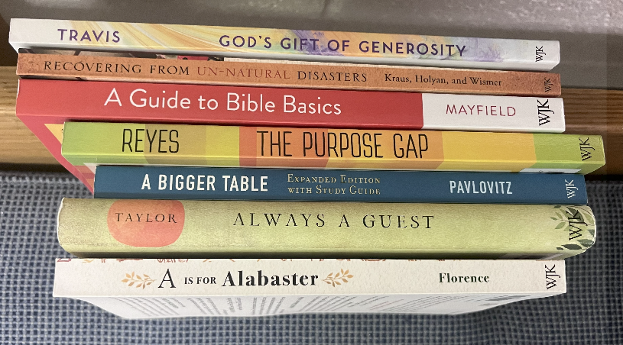

• *A Guide to Bible Basics* by Tyler D. Mayfield

• *The Purpose Gap* by Patrick B. Reyes

• *God’s Gift of Generosity* by Karl Travis

• *Recovering from Un-Natural Disasters, A*

*Guide for Pastors and Congregations after*

*Violence and Trauma* by Laurie Kraus, David

Holyan, and Bruce Wismer

• *Always a Guest* by Barbara Brown Taylor

• *A Bigger Table* by John Pavlovitz

• *A is for Alabaster* by Anna Carter Florence

These can be found on the book shelf in the sanctuary or check with Jen.

**CPC ARTIST:**

****We are thrilled to share that we have a new instructor for our CPC Artist class!  Catherine Homrighaus is an active friend of CPC. Her mother is Reverend Barbara Esterly whom supply preaches for CPC. With husband Steve they have two daughters, Iva & Josie.  She has a BFA from the University of Cincinnati. When she’s not crafting at home with the girls, she works a couple of days at their family business, Welder Service Co. Catherine led our artists in June in painting a firefly piece which is currently on display in our "CPC Artist Gallery". Our next class will be Sept. 9th at 5pm as we take a short summer break. Advanced registration is required for this free class. Watch for the sign up towards the end of August.

**CPC TUESDAY SCHOOL:**

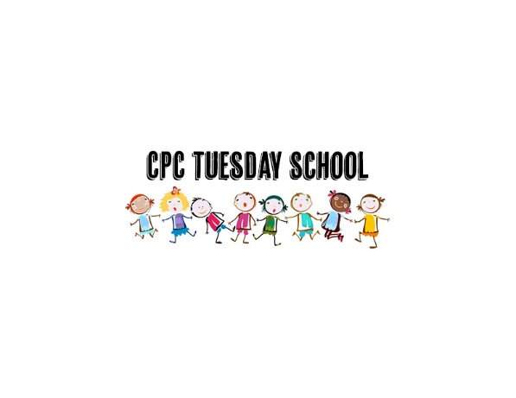Registration is open for the 2025 - 2026 CPC Tuesday School program. CPC Tuesday School is a faith-based play and learn program for children ages 2.5 - 5 years. Children will experience God’s love through story, craft, music, and play. Our staff is made up of volunteers from our church that have a passion for ministering to children and sharing God’s love with them. We offer a structured environment where each child can explore, learn and experience being part of the Body of Christ. Children must be potty trained. A $30 donation is requested to help cover the cost of supplies for the year.

Contact Jen Juhasz for more information regarding this program [jencpctoledo@gmail.com](mailto:jencpctoledo@gmail.com) or use this link to register:  [CPC Tuesday School Registration Form](https://docs.google.com/forms/d/e/1FAIpQLSeoQRrx3nGVVR5BCiTJRN8iX6fxTonp5datB-zexSioV7t3Ww/viewform)

**CHANCEL FLOWERS**:

The Worship Committee needs volunteers to sign up to provide bouquets for our church services. If you enjoy arranging flowers, this would be a wonderful way to help serve the church. The flowers are used for anniversaries, memorials, for the homebound, etc. There will be a sign-up sheet on the information table located in the Narthex. The sign-up sheet will ask for your name and phone number so we can contact you and give you more details concerning the Chancel Flowers.

If you have any further questions, please contact Carolyn Collins, Worship Committee Chair at 419-205-6400 or email to [fritzecjc58@gmail.com](mailto:fritzecjc58@gmail.com).

**STEWARDSHIP:**

Per Capita is $40.29 per member. Be sure to label “per Capita” when submitting to Amalya.

Total Income (Jan-May) $ 178,927.42

Total Expenses $ 214,637.87

Net Income ($ 35,710.45)

**DINNER GROUPS**:

Get to know the people sitting next to you in our church! Sign up for our dinner groups on the form in the narthex. We will begin in September. Each person or couple will be responsible for organizing a place, date, and time for an assigned month. If you have any questions, please contact Diane McClellan at 419-460-3412 or [dianefrogs@aol.com](mailto:dianefrogs@aol.com). This is for all members, so please join us!

**PRAYER MEETING**:

Beth Bedwell and Howard Wharram will be leading a Prayer Meeting in the Chapel on Tuesday evenings, beginning at 7PM. Everyone is welcome to attend. If you have prayer concerns and cannot be there, please contact Beth or Howie.

**CELEBRATING BIRTHDAYS**:

These CPC members are celebrating a birthday this month and we wish them a wonderful year ahead!

***Leslie Backoff; Gary Connor; Peter Mezo; Sharon Olson; Constance Haberkamp 7/2;***

***Ryan Bossenbroek 7/6; Shirley Boyer 7/6; Bruce Wharram 7/6; Kathy McGannon 7/13; Barbara Brownlee 7/14; Griffen Barkley 7/18; Carol Lydy 7/19; Granger Souder 7/25;***

***Phillip Mintun 7/26; Tim Pryor 7/26.***



**CARE AND CONCERN**:

***Homebound****:*

Mary Ignat, Jama Roman, Harry Tubbs, Peg Locker

***Ongoing concerns***:

Jack Rogers, Linda & George Bell, Sherry Gilbert, Barbara & Richard Brownlee, Don & Sandy Townsend, Margie Olsen, Jean Oldham, Millard Stone, Him & Sanda Findley.

***Deaths:***

Millard “Stoney” Stone on June 21, 2025

***Relatives and Friends***:

Robert Wagner (Jim Wagner’s brother)

Evelina & Mark Scala (Friend of Robert Mark)

Debbie Profitt (surgery on 3-4 at Toledo Hospital)

Gary and Louise Pikor (friend of Rick Stanbaugh)

Vickie McKeever (Jen Juhasz’s mother)

Kelly Dammon (Jen Juhasz’s cousin)

Joe & Barb Esterly (Joe in ICU at Flower Hospital)

Carol (Karen Wharram’s sister)

Tim Pryor & Betsy Gouvemayre

**CLOSING PRAYER**:

Creator God who breathed this world into being, who is visible within the harmony of nature, the perfection of a butterfly’s wing, the grandeur of a mountain range, the soaring eagle and hummingbird, thank you for this summer world which you have created. Thank you for summer sun, which reminds us that your creative breath is still alive and active. Thank you for the summer warmth of your love which sustains this world, your garden and our home.