CHRIST PRESBYTERIAN CHURCH NEWSLETTER
JANUARY 2026


DEVOTIONAL:
As believers in 2026, let us take the path of optimism, patience, and goodness. Take a leap of faith and begin this wondrous new year by believing. Believe in yourself. Remember, God is not moved or impressed with our worship until our hearts are moved and impressed by Him.

REMINDER:
As winter approaches, you are reminded if Lucas County is in a Level 2 or 3 Snow Emergency, all church services & programming will be cancelled. Check your local TV stations for Level alerts.

STEWARDSHIP:
CPC is beautifully decorated throughout Advent and Christmas and reminds us of 2025 drawing to an end. Please complete your 2025 pledges by January 6th and any gifts given to CPC as the year concludes are greatly appreciated. Please prayerfully consider your 2026 pledges and gifts to the Operating Fund and let us know your plans. On Dedication Sunday, November 9th, many pledges were received and comments were made by Stewardship Chair, Phil Mintun. Check out Howie Wharram’s Stewardship sermon from Oct. 12th on our YouTube channel.

The financial commitments for 2026 are tracking as pledges were for 2025. One of our goals is to give the CPC staff a cost-of-living increase, so all amounts pledged and given are helpful.

Per Capita is $40.29 per member. Be sure to label “per capita” when submitting to Amalya.

Here are the financial figures for January – November 2025

Total Income $520,624.14
Total Expenses $473,221.55
Net Income $ 47,402.59

Due Dates for 2025 Donations and Reimbursements and 2026 Pledge Cards
- Donations to be applied to 2025: must be received by Tuesday, January 6th
- Reimbursements to be included in 2025: must be submitted by Monday, January 5th
- Pledge Cards for 2026: Received by Tuesday, January 6th

If mailing, please send early to allow for delivery time.
Also, please be sure to clearly label which year each item should be applied to.

WALK WITH US:
The CPC Healthy Path will open for members January 12th – April 30th. It is a ¼ mile path that can be repeated for longer walks throughout the church halls. The days are Monday, Wednesday and Thursday and the hours are 8:30AM – 10:30AM. Enter through Hansen Hall Door. Sign in and enjoy a warm walk. If you have any questions, please contact Diane McClellan 419-460-3412.

EDUCATION COMMITTEE:
The committee has changed the time for their monthly meetings to 6PM on the third Wednesday of each month. Anyone interested in joining our group, please contact Jen Juhasz or Diane McClellan.

CHILDREN & FAMILY MINISTRY
CPC ARTIST:
Children ages 4 and up are invited to an instructor led canvas painting class January 6th at 4:30pm in Hansen Hall. Artwork will be displayed in our “gallery” then taken home. The class is free and advanced registration is required. Contact Catherine: 513-659-9253.

WORSHIP LEADERS & ACOLYTES SIGN UP:
Please use the links in the weekly constant contact under the Children & Family Ministry section to sign up your child and/or youth to be an integral part of worship here at CPC! These are wonderful opportunities for young people to be participate and engage in the weekly worship life of the congregation.

BEAT THE BULLIES:
In a world that can sometimes feel negative, judgmental, or just plain mean, it’s more important than ever to take an all-in approach to creating a life where everyone feels welcome, valued, and safe around you.

Refusing to settle for a culture of bullying, drama, or peer pressure is the key to building an environment where we all can thrive — mentally, emotionally, and socially. In this session, you’ll get real talk, real data, and real stories that will make you laugh, maybe tear up, and definitely think differently about how you treat others (and yourself). You’ll walk away with practical ways to build empathy, show kindness, and create positive change in your world and your story. Because the best investment you can make… is investing in people — starting with you.

KID’S DAY:
January 19th from 9AM – 3PM. Children from the ages of 5 through 5th grade is invited to join us for a fun day at CPC. We have some exciting activities planned for the day & lunch is included. The cost is $5 per child and advanced registration is required by Jan. 13th. Contact Jencpctoledo@gmail.com to register.

YOUTH GROUP MONTHLY GATHERING:
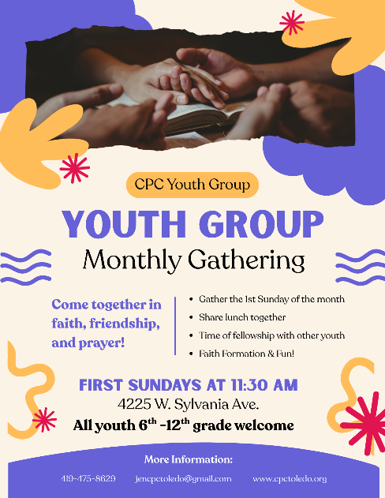
CPC Youth Group will gather the first Sunday of each month at 11:30AM in the youth room. We will share lunch together along with faith formation & fun! Youths 6th grade - 12th grade are invited to join us for this meaningful time.

January Youth Group:
1/04: Monthly Youth Gathering & Lunch
1/11: Second Sunday All Church Luncheon
1/11: Beat the Bullies with DR. KP – 6PM
1/18: Youth Service Day - 10:30AM
1/19: Youth Volunteers needed for Kid’s Day – 9AM to 3PM

YOUTH & FAMILY RETREAT:
Feb 6th - 8th Youth and their families are invited to gather for a weekend of fun & fellowship. We will be staying at Kirkmont Center and hope to go tubing at Mad River Mountain on Saturday! Let us know ASAP if you can join us so we can plan accordingly and purchase tickets! RSVP to Jencpctoledo@gmail.com

YOUTH SERVICE DAYS:
January 18th the youth will head downtown to serve with 419 Cares. We will plan to sit together in worship that morning to receive a blessing as we depart about 10:30AM. We also need youth volunteers for Kid’s day on January 19th from 9AM – 3PM!

YOUTH GROUP LUNCH VOLUNTEERS: Youth Group will be meeting the first Sunday of the month and we would love to have your help providing lunch for them! Use the link in the weekly constant contact under the Youth Ministry section to sign up! You can prepare lunch yourself or order in. We can reimburse you or you can donate your time & lunch. This is a great was to support & connect with our youth! THANK YOU!

PRAYER GATHERING:
Join us Tuesdays at 7PM for weekly prayer meetings in the chapel as we gather to lift up prayers. Beth Bedwell and Howie Wharram will be leading. If you cannot be present, prayer requests can be sent to Howie at Jeffery_1972@Yahoo.com.

DEBORAH CIRCLE:
Join us every second Wednesday at 12:30 PM. The study is called “Finding Resilience, Joy and our Identity in Jesus Christ”. Study books will be available for purchase. Please contact Beth Bedwell with any questions.

CELEBRATING BIRTHDAYS:
These CPC members are celebrating a birthday this month and we wish them a wonderful year ahead!


Jennifer Juhasz 1/2; Rosalyn Pearson; Richard Springman; Ruth Summers; Robert Dedo 1/5; Jim LaRue 1/5; Jane Mintun 1/6; Tom McGannon 1/9; Roger Start 1/10; Dave McClellan 1/11; Susan Moyer 1/12; Carrie Johnson 1/13; Matthew Mintun 1/15; Anne Taylor 1/17; Tim Schmidt 1/18; Jeanne Miner 1/29; Gage Barkley 1/30.

CARE AND CONCERN

HOMEBOUND:
Mary Ignat, Jama Roman, Peg Locker, Harry Tubbs, Kathy McGannon

ONGOING CONCERNS;
Jim Burns, Gary Connor, Kay Sellers, Betsy Gouvernayre, Judd Collins, Bill Drake, Jack Rogers, Dee Tilley, Dave McClellan, Richard Stambaugh, Christine Vischer, Harry Tubbs, Sherry Gilbert, Barbara & Richard Brownlee, Don & Sandy Townsend, Margie Olson, Kathy Batdorf, Linda Bell, Stephanie & Jenny Bell, Jim & Sanda Findley, Jean Oldham, Bruce Wharram, Katie Wharram

DEATHS:
Anne White, sister of Jeannie Miner & former CPC member, died November 17, 2025

RELATIVES AND FRIENDS:
Sam Tekyimensah (friend of Comfort Ofori)
Loraine Gilley (friend of Bill Drake)
Stevie Linville (nephew of Kim Dedo)
Maverick (6-month-old friend of Kim Dedo)
Fred Heumann (Missionary)
Jim Armagast (father of Brandon Armagast)
Ann Saudmore (Hattie Kate Howell)
Judy Clendenin (mother of Rev. Ruth E. Clendenin)
Ryan Blocher (son of Carolyn Collins)
Alex (nephew of Jane & Phil Mintun)
Harel Carrier (friend of Bill Drake)
Terry Drake (brother of Bill Drake)
Perry Bates (friend of Tyson Fankhauser)
Robert Wagner (brother of Jim Wagner)
Anthoney & Danielle Ferrer (friends of Katie Wharram)
Terri Jo Schempf (niece of Carolyn Collins)
Jean Crisp (Howard Wharram)
Aaron Grizaniuk (son of Pat & Tony Grizaniuk)

CLOSING PRAYER:
God Eternal, thank you that you make all things new. Thank you for all that you’ve allowed into our lives this past year, the good along with the difficult things, which have reminded us how much we need you and rely on your presence filling us every single day. Help us enjoy 2026.

